**Add a Lifecycle Configuration Rule to a Bucket**

Sign in to the AWS Management Console and open the Amazon S3 console at <https://console.aws.amazon.com/s3/>.

Create the bucket ( Refer Lab 1 to create new bucket )

Click on the bucket and choose Lifecycle and click add Lifecycle rule

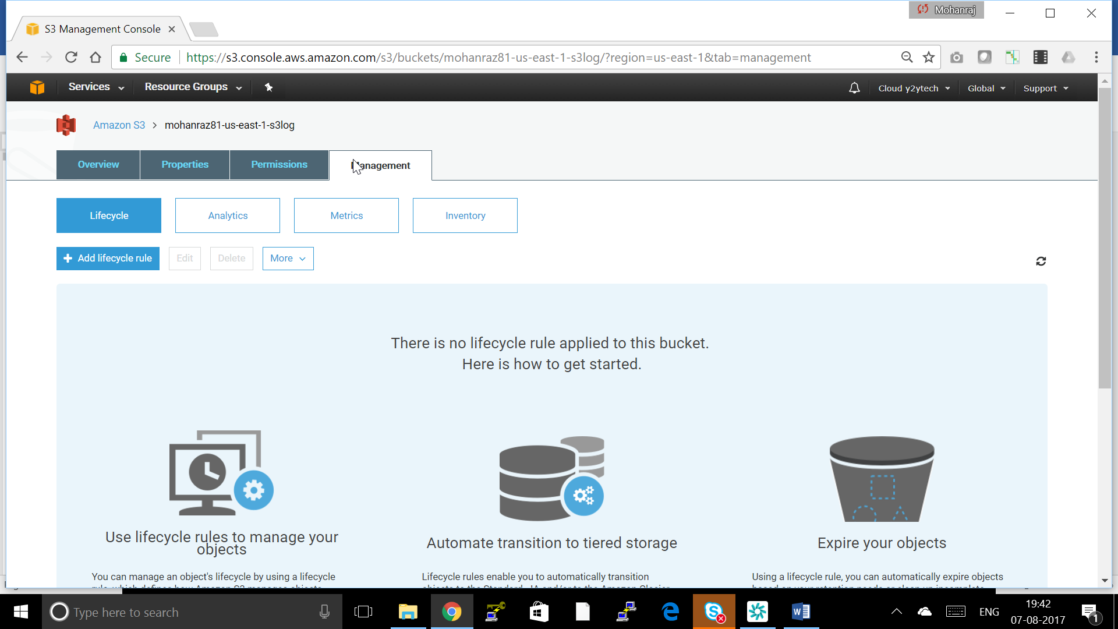

Add Rule name and Scope Leave empty for whole bucket or you can give a folder of the bucket

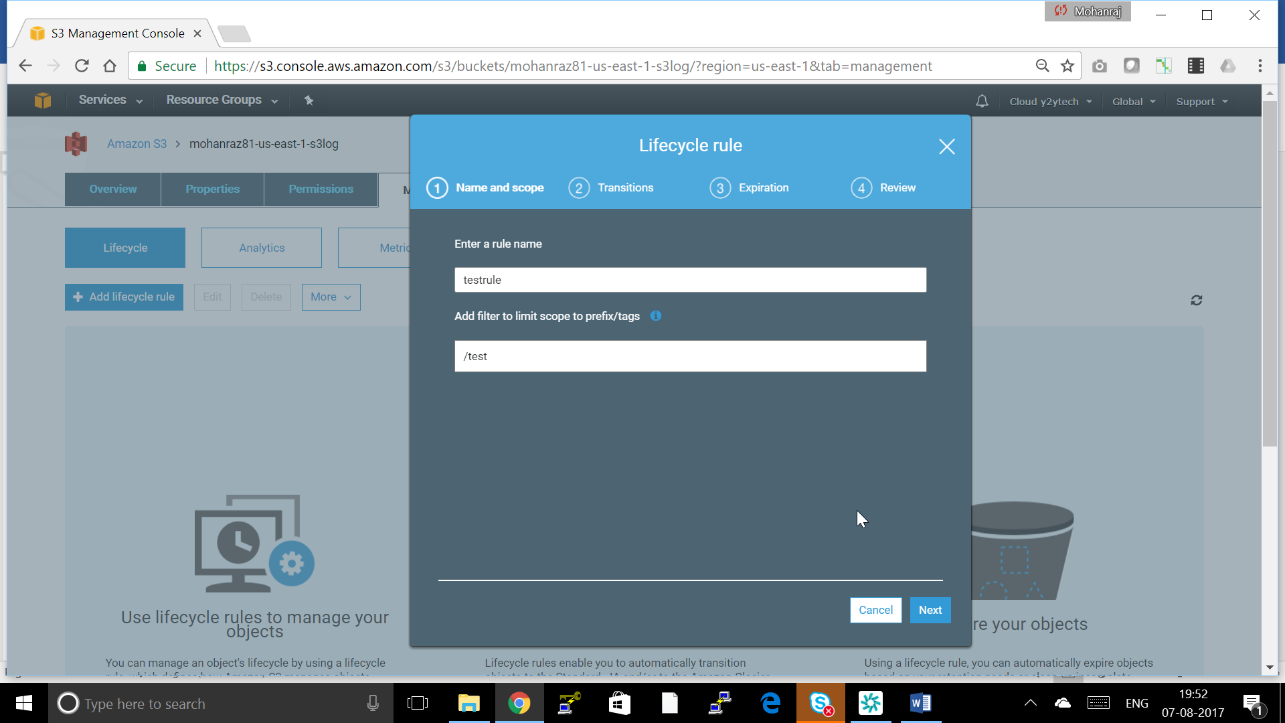

Choose the vesions you want to transition and click on add a transitions and choose transitions to Glacier after choose 1 day and say Next

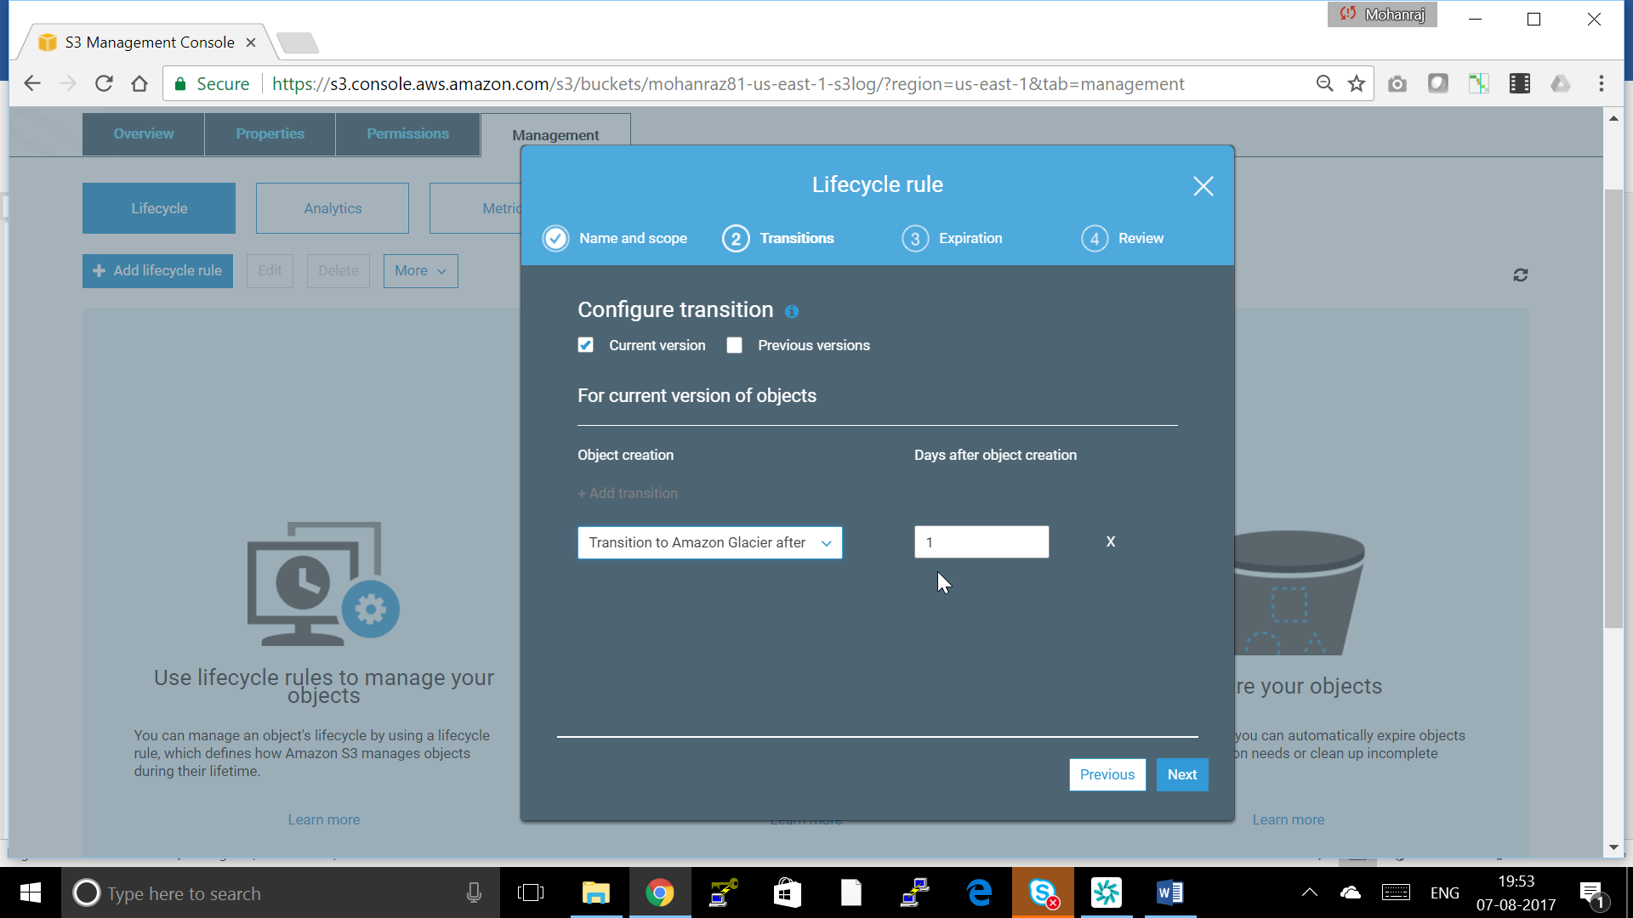

Set when you have to delete the data after how many days of transition

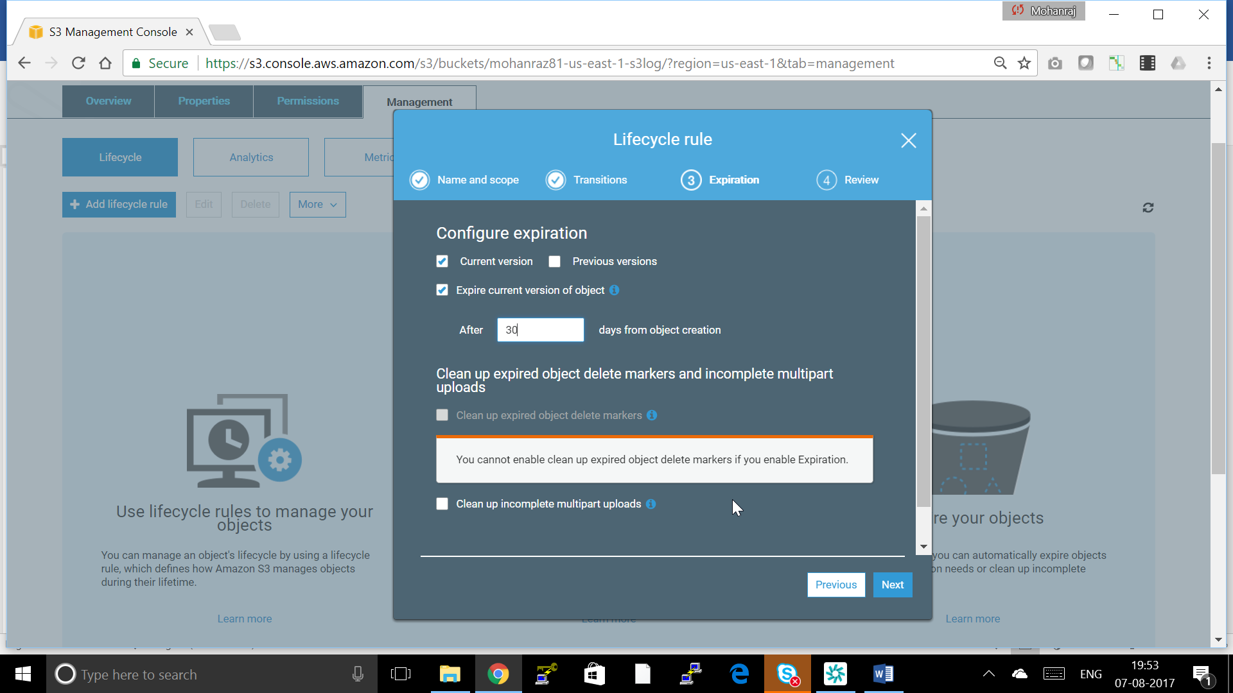

Review and Save

